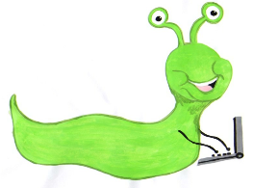 | Lyng Primary School Knowledge Organiser  Computing |  | 
Topic: Computing | How can computers be used? | Year 1 | Spring 1


What Goldilocks and Step On words will I use?
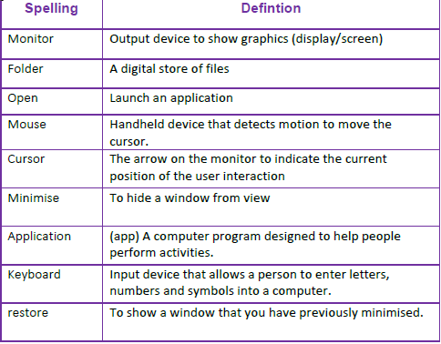
Aims of this unit
Use technology purposefully to manipulate and retrieve digital content. Use technology safely and respectfully.
- Using a mouse
- Switch on and shutdown
- Launch and manipulate applications and windows
- Locate folders and save files
- Drag using a mouse
Safeguarding
Filtering and monitoring system is in place. Children will use their own log in details to track any misuse and to protect the child from harmful websites and pop ups. Children will be reminded of how to stay safe online and to use technology safely and respectfully and to tell a trusted adult if there is anything on their computer that makes them uncomfortable.

Outcomes
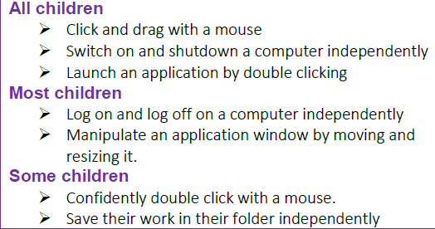
Agreed outcome
Program a toy
Spring Term
Computer Skills

In this unit…
Children will learn the basic skills that they need in order to be able to use a desktop computer. Children will learn how to use a computer mouse and how to switch on and shut down a computer. They will apply their mouse skills by launching applications, manipulating windows and opening and saving files and folders. The children will then practice their clicking skills and learn to drag objects.
:

